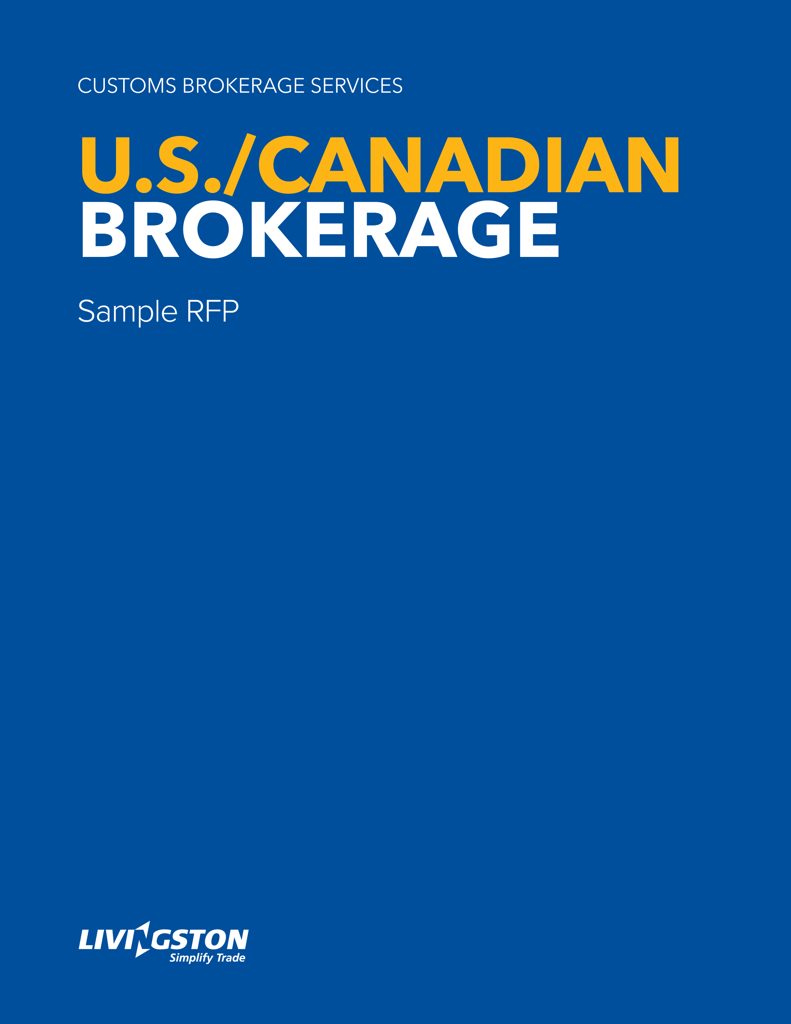

SAMPLE RFP: Introduction
This is an introductory template that can be used as a basis for a brokerage RFP. We have gathered together some of the most relevant and commonly asked brokerage questions to help you get on your way with your procurement.
Please feel free to adapt this document so that it reflects your vendor needs and business goals.
The document is broken down into six sections:
PART 1.0 Scope
PART 2.0 Evaluation and award
PART 3.0 Terms and conditions
PART 4.0 Company profile
PART 5.0 RFP questions
PART 6.0 Pricing

The use of the term <COMPANY> refers to you, the issuer.
“Bidder” refers to the company responding to your RFP.

Table of contents

PART 1.0 Scope …………………………………………………………………………………… 4
  - Use of proposal of ideas …………………………….………………………………… 4

PART 2.0 Evaluation and award ……………………………………………………..………… 4
2.1 Timetable ………………………………………………………..……………………… 5
2.2 Bidder questions ……………………………………………..…………………...…… 5
2.3 Submission of proposals …………………………………….………………..……… 5

PART 3.0 Terms and conditions ……………………………………………………..………… 6

PART 4.0 <COMPANY> profile …………………………………………………….…………… 6

PART 5.0 RFP questions …………………………………………………………….…..……… 9
5.1 Bidder information …………………………………………………………..….……… 9
5.2 Company operations ……………………………………………………….….……… 9
5.3 Technology and reporting ………………………………………………….….……… 11
5.4 References ………………………………………………………..…………….……… 11

PART 6.0 Pricing …………………………………………………………………………..……… 11

PART 1.0: Scope
This Request for Proposal (RFP) details <COMPANY>’s requirements from its customs brokerage provider (Broker) for the import of goods into Canada/US. The selected bidder will be responsible for processing <COMPANY> import documents for CBSA/CBP (Customs) entry and clearance, providing detail for management of <COMPANY>’s duty and tax payment process.
This RFP outlines the specifications and requirements but not all of the terms and conditions, which will be incorporated into the contract between <COMPANY> and the successful bidder(s).
<COMPANY> will evaluate all bidders’ proposals received by the submission deadline. Responses received after the deadline will not be considered. Distribution or receipt of any proposal does not constitute a commitment by <COMPANY> to any or all bid participants. If it is determined that the submitted proposals are not beneficial to <COMPANY> due to pricing or for any other business reason, <COMPANY> may, at its sole option, reject all, or further negotiate with bid participants.
This is not a binding contract. Please note that <COMPANY> does not have any legal obligation whatsoever to your company or any other bidder, unless and until a definitive Agreement has been fully executed and delivered.
<COMPANY> reserves the right to change the schedule and/or cancel the RFP process at any time, with or without notice.

1.1 Use of proposal ideas
<COMPANY> has the right to use any or all ideas presented in any proposal received in response to this RFP. If a bidder does not want specific proprietary information used, a written request must be included in their RFP, specifying which proprietary information is to be kept confidential.
A request will not be considered valid with respect to the use of ideas that are not the proprietary information of the bidding company and so designed in the proposal, or which:
- Were known to <COMPANY> before such proposal;
- Properly became known to <COMPANY> thereafter through other sources or through acceptance of company’s proposal;
- Are generally known publicly.

PART 2.0: Evaluation and award
- <COMPANY> intends to award the work to the most responsive and responsible bidder, whose proposal offers the best value to <COMPANY>. However, <COMPANY> is under no obligation to award any contract in whole or in part and <COMPANY> reserves the right in its sole discretion to cancel this RFP process any time before or after closing without providing reasons for such cancellation.
- The lowest pricing of any proposal may not necessarily be accepted.
- All proposals will be evaluated on the following criteria:
- Price;
- Experience;
- Completeness of proposal;
- Any other value-added benefits

- In order to obtain the most advantageous offer for <COMPANY>, <COMPANY> reserves the right in its sole discretion to:
- Discuss any and all proposals and to request additional information from bidders;
- Waive any irregularities or omissions in any proposal;
- Modify target dates;
- Accept or reject any or all proposals in whole or in part
- Negotiate for the modification of any single proposal;
- Request clarification and additional information on any proposal.

2.1 Timetable
TIMETABLE | DATE
RFP release date
RFP question period
Bidders’ questions due
Response due
Initial evaluation process complete and notifications sent
Preferred service provider presentations
Provider selected
Commence implementation

2.2 Bidder questions
Any questions concerning the RFP must be addressed, in an electronic format to:
<CONTACT INFORMATION>
Questions should clearly identify the relevant sections of the RFP. Responses to questions, either written or orally, will not amend the RFP unless, and until, the response is included in a formal amendment to the RFP, which <COMPANY> will submit to all bidders.

2.3 Submission of proposals
Please send your electronic files (PDF or Word) upon completion to:
<INSERT NAME> and <CONTACT INFO>
The deadline for receiving your completed proposal is: <INSERT DATE>
If your proposal merits further consideration, we will contact you to schedule a future meeting with you and your company’s decision-makers.

PART 3.0: Terms and Conditions
- All terms, conditions requirements and provisions of the RFP are deemed to be accepted by bidder unless bidder has indicated non-compliance in its response to the RFP.
- All information contained in this RFP and any information disclosed by <COMPANY> during the evaluation period is considered confidential information. By accepting this RFP, bidders agree not to disclose this RFP, or any of its content, to any external parties without the express written consent of <COMPANY>.
- All documents supplied with this RFP remain the property of <COMPANY> and must be returned upon request.
- All proposals received become the property of <COMPANY> and will not be returned. <COMPANY> shall have the right to use any or all systems, ideas or adaptations of the ideas presented in any proposal received in response to this RFP. Selection or rejection of the proposal will not affect this right. Any restriction on the use of data contained within your proposal must be clearly stated in the proposal itself. Proprietary information submitted in response to this RFP will be handled appropriately and confidentially.
- All Respondents and Proposals must comply with all laws applicable to the goods and services provided pursuant to the final form of agreement.

PART 4.0: <Company> profile
Below is a breakdown of <COMPANY’s> statistical information regarding imports and exports. These facts should help bidders in the pricing and completion of the RFP so as best to comply with <COMPANY’s> requirements.
By completing this process, <COMPANY> aims to select an approved and compliant broker to act on our behalf when making import and export declarations to local governmental authorities.

CANADA | <COMPANY TO INSERT THEIR DATA PRIOR TO ISSUING OF RFP>
Number of imports, broken down my monthly totals
Percentage of shipments, broken down by mode of transport:
Courier
Truck
Air
Ocean
Rail
Percentage of High Value Shipments (HVS) valued at above CA$2,500.00 per shipment
Percentage of Courier Low Value Shipments (CLVS) valued at below CA$2,500.00 per shipment and submitted through a recognized courier
Average monthly GST outlay
Average monthly duty outlay
Lines per entry:
Average
Minimum
Maximum
Percentage of shipments with Other Government Department (OGD) involvement? (e.g., CFIA – Canadian Food Inspection Agency)
Tariff details:
Number of items
List of data elements
Format to be provided
Timing it will be available
Confirm whether you have direct security with CBSA for remittance of duty and tax?
If yes: Program description
Funds disbursed by the broker on <COMPANY’s> behalf
Invoicing: Paperless or EDI
Are there opportunities for electronic Canada Customs Invoices (CCIs)?
Are there any other forms disbursements
(i.e., storage, freight, etc.)?
If so, what is the average dollar amount monthly?
NAFTA management process overview:
B2 Activity
Average number per month, reason (HS,
Value other)
Top ports of entry
Top countries of import
Most utilized FTA and Special Programs
Percentage of non-classified goods for entry purposes
Percentage of non-classified goods for AES purposes
Average number of lines for manual AES

United States
Number of imports, broken down my monthly totals
Percentage of shipments, broken down by mode of transport:
Courier
Truck
Air
Ocean
Rail
Lines per entry?
Average
Minimum
Maximum
Percentage of shipments that have participating government agency involvement?
Which agencies are involved?
Does your company have a product database?
Provide sample of database for review
Invoicing: Paperless or EDI
Are there opportunities for electronic Commercial Invoices (CIs)?
Are there any other forms disbursements
(e.g., storage, freight, etc.)?
If so, what is the average dollar amount monthly?
What is the annual outlay the broker would be expected to pay yearly on your behalf (e.g. storage, freight, duty, etc.)
ISF process details
NAFTA management process overview:
Top ports of entry
Top countries of import
Most utilized FTA and Special Programs
Percentage of non-classified goods for entry purposes
Percentage of non-classified goods for AES purposes
Average number of lines for manual AESs
Number of shipments that are subject to ADD/CVD
<CONSIDER PROVIDING ITRAC OR ACE DATA FOR BROKER ANALYSIS IN PLACE OF U.S. TABLE ABOVE.>

PART 5.0: RFP Questions

5.1 Bidder information:
- Number of employees in Canada and U.S.?
- Number of offices in North America and where are they located?
- Please provide your corporate or primary address.
- Number of years in operation as a customs broker.
- Besides brokerage services, please describe all of your other lines of business.
- Hours of operation, including after-hours, weekends, and holiday capabilities, whether or not employees are on call 24 hours a day.
- Please detail your company’s corporate structure. Attach an organization chart with key personnel names and titles.
- Has your company made any acquisitions in the past two years?

5.2 Company operations:
- Do you have a BCP in place? Please provide details.
- How many customs entries does your company file per year?
- What services do you offer as support for carriers crossing the border to ensure a timely release process?
- Is your company a member of C-TPAT (Y/N)? If yes, please provide year certification and SVI Number.
- Is your company a member of PIP (Y/N)? If yes, please provide year of certification.
- Can your system track NAFTA savings and NAFTA gains for possible duty recovery?
- Identify how your firm would be able to “receive” and manage NAFTA information provided by <COMPANY>.
- Does your company maintain a country-wide HS classification database to ensure consistency of classifications applied to a particular part number? Please provide details as to how this is captured, maintained and accessed for future imports by your brokerage employees.
- Do you operate a national operating system?
- Is your system capable of accepting a parts database?
- Provide a brief overview of your company’s experience with FDA and CFIA regulated products.
- Define how Standard Operating Procedures (SOP) are synchronized with clients’ specific requirements. How does your company maintain client SOPs and instructions?
- Does your company offer a process for electronic or paperless invoicing? If so, please describe the process.
- How do you keep your clients updated on changes to the regulatory and trade environment?
- What distinguishes your compliance program from your competitors?
- Describe your internal compliance program.
- Does your company conduct regular self-compliance audits? If yes, please describe this process.
- Please describe your implementation plan when transitioning from another supplier.
- How would your company manage our account on a daily basis?
- Can your organization provide dedicated, experienced account representation?
- What type of quality control procedures does your organization have? Is there a corrective action plan in place? If so, please explain your corrective action procedure for handling errors,
complaints, etc.
- Describe your company’s systems and processes for handling a client’s inquiry or issue.
- How do you measure your client satisfaction rate?
- Describe your processes for reviewing the service delivery performance information to identify and track preventive actions and improvements needed to maintain client satisfaction.
- Has your company had experience in supporting its clients with Customs audits?
- Does your company have the capability to prepare and file reconciliation entries under the Customs ACS Reconciliation Prototype based on data given you by authorized <COMPANY> employees?

- What training programs do you offer to your clients and the industry in general?
- What distinguishes your company from your competitors?

5.3 Technology and reporting:
- What is your website’s capability for tracking shipments?
- What type of reporting capabilities can your company offer?
- Would <COMPANY> have the ability to run reports via a web-interface?
- Is the data real-time?
- Are all events within the brokerage systems available for reporting?
- Is this an additional service fee?
- What types of reports are available? (Standard and ad-hoc)
- Confirm turnaround time for requested data.
- Provide an overview of the IT Support Department within your organization. Are there dedicated IT support professionals?
- Is imaging technology available? Please provide a detailed overview of functionality.
- How long are imaged document files maintained?
- What are your EDI capabilities?

5.4 References
Please provide the names of two references for which your firm was contracted to do work. Please include their contact information, the operating company for which they work, and a description of the scope of work.

PART 6.0: Pricing
< USE THIS SECTION TO IDENTIFY YOUR PRICING REQUIREMENTS.>

